LECCIÓN 6.5 Hoja de trabajo

Códigos

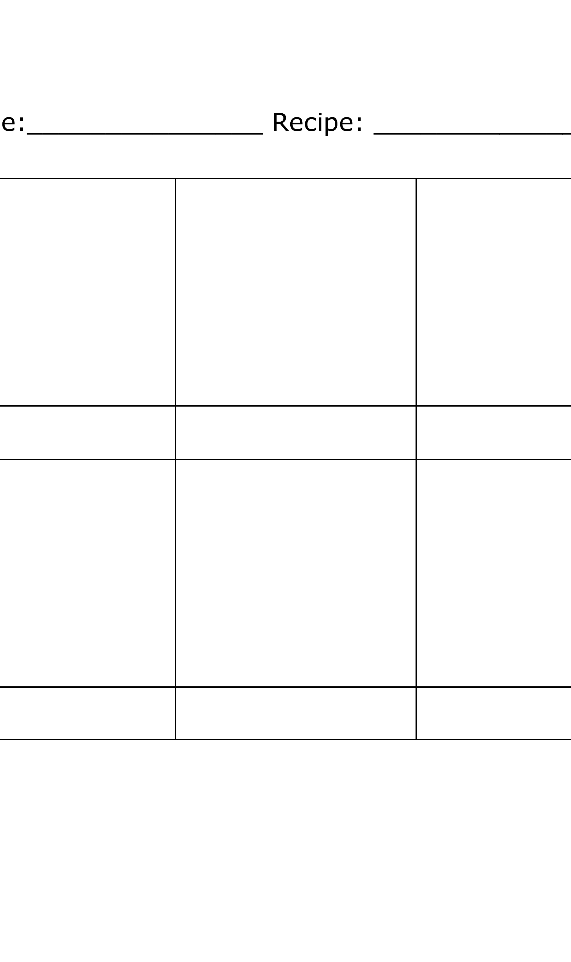

|  |  |  |  |  |  |  |  |  |  |  |  |  |
| --- | --- | --- | --- | --- | --- | --- | --- | --- | --- | --- | --- | --- |
| A | B | C | D | E | F | G | H | I | J | K | L | M |
| N | O | P | Q | R | S | T | U | V | W | X | Y | Z |
|  |  |  |  |  |  |  |  |  |  |  |  |  |
| Z | Y | X | W | V | U | T | S | R | Q | P | O | N |
| M | L | K | J | I | H | G | F | E | D | C | B | A |

Decodifica estos mensajes.

**1** RY PBQVTB RF IBYNE.

________________________________________

**2** INZBF N TNANE.

________________________________________

**3** ZR THFGN QRFPVSENE PBQVTBF.

________________________________________

¿Puedes escribir tu nombre usando el código secreto   
del alfabeto reverso?

____________________________________